NAME : AFFAN AHMAD ENROLLMENT : 03-134221-003

SOME APPLICATION OF FIRST ORDER DIFFERENTIAL EQUATION

Introduction:

There are many applications of first order differential equations to real world problems,

the following linear and non-linear models as an application:

* **Cooling/ and warming law**
* **Population growth and decay**
* **Harvesting renewable natural resources**
* **Prey and predator**
* **A Falling object with air resistance**

**Question No. 1**

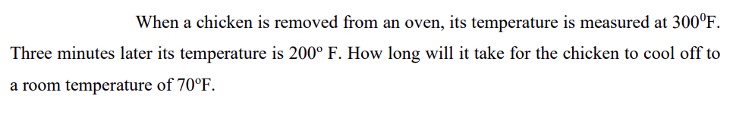

we put Tm = 70 and T=300 at for t=0.

T(0)=300=70+c2eα.0

This gives c2=230

For t=3, T(3)=200

Now we put t=3, T(3)=200 and c2=230 in (4.1) then

200=70 + 230 eα.3

or 

or 

or 

Thus T(t)=70+230 e-0.19018t (4.2)

We observe that (4.2) furnishes no finite solution to T(t)=70 since

limit T(t) =70.

t→ ∞

**Question No. 2**

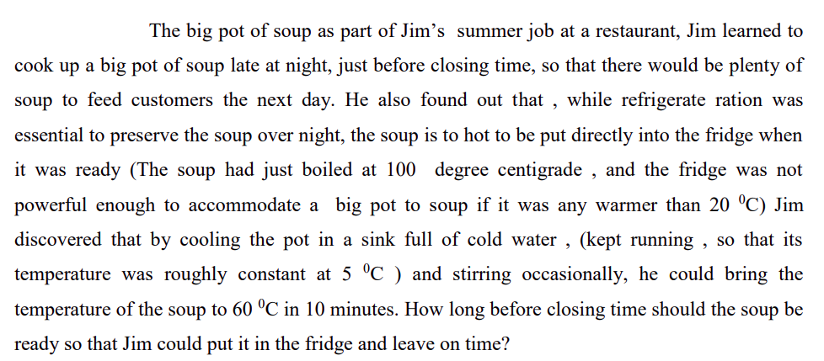

Let T(t) represent the temperature of the soup at time t. Measure T in degrees C and time in minutes. Start time when the soup is ready. We will find the t that causes T(t) to equal 20. The Differential Equation is dT dt = k(T − 5). The initial condition is T(0) = 100. The information T(10) = 60 will help us find the constant of proportionality.

Separate the variables and integrate

Z dT /T − 5 = Z kdt

ln(T − 5) = kt + C

T − 5 = e Ce kt

Plug in the initial condition to evaluate the constant:

100 − 5 = e Ce

We now know that the temperature of the soup at time t is:

T(t) = 5 + 95e kt

Plug in the information that tells us k:

60 = T(10) = 5 + 95e 10k

55/ 95 = e 10k

ln( 55 /95 )/ 10 = k.

The soup has cooled to 20 degrees when

20 = T(t) = 5 + 95e kt

ln( 15 /95 )/ k = t

10 ln( 15/ 95 ) /ln( 55 /95 ) = t

The soup should be ready 10 ln( 15/ 95 )/ ln( 55/ 95 ) minutes before closing time